Assignment1:
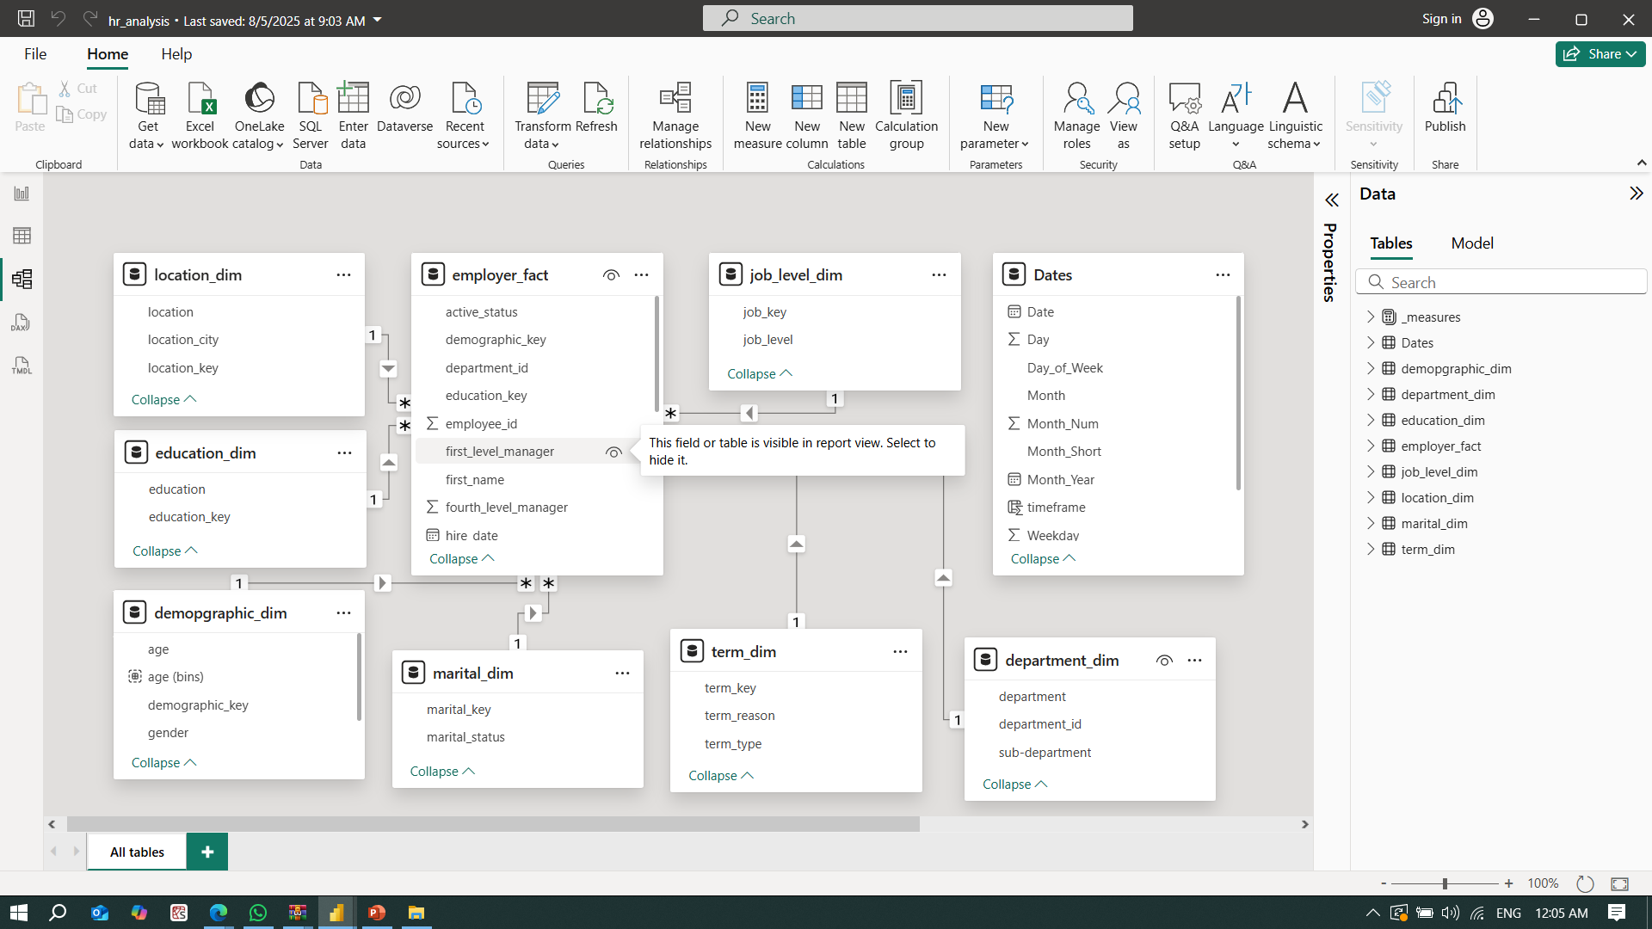

1-Use the next csv files in order to generate the above model
people_data.csv
people_employment_history.csv
2- Connect to files then open power query to divide people_data.csv files to achieve needed schema.
3- Replace column birth_date by age(in years)

Hint:
You will reference to main file then use remove columns, add index key and merge queries in your assignment.
4- Make sure relation is correct between all tables.

Assignment2:
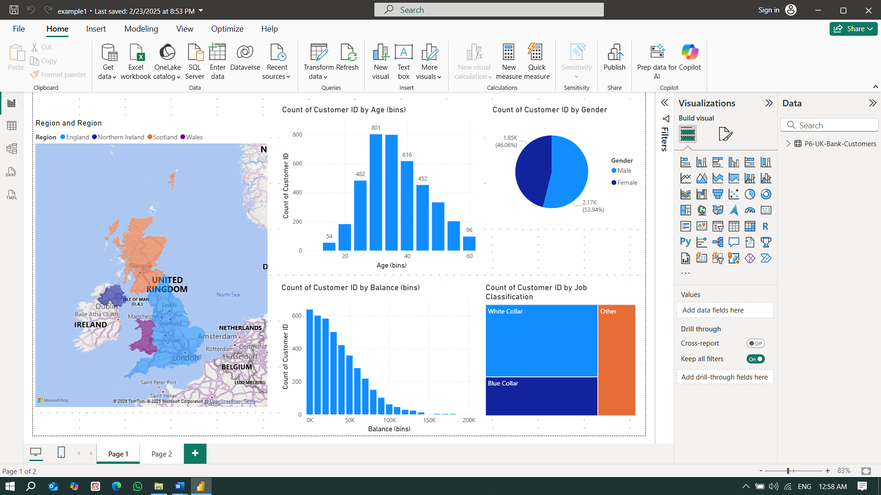

Use P6-UK-Bank-Customers.csv to generate the above segmentation dashboard.

